Dr. Fraud J. Michael Skiba, MBA. PhD

 |  | 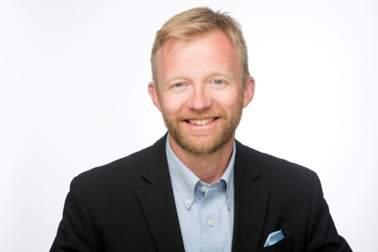
www.drfraud.org

https://www.linkedin.com/in/jmichaelskiba

https://www.youtube.com/channel/UCB1tg7ky8HeNwsw-UdHm0Fg

https://dr-fraud-training-group.thinkific.com/

jmichaelskiba@gmail.com

P.O. Box 128
Wynantskill, NY 12198

518-527-2222

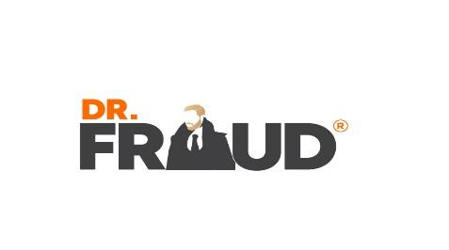
“Dr. Fraud was one of most dynamic and informative speakers I have ever seen”!  Mario Pecoraro-CEO Alliance Worldwide | Dr. Fraud has over two decades of international economic crime experience (academic, public and private sector) and currently owns his own consulting company where he is available internationally for consulting, speaking, and training either on-site or remote. He has performed at over 300 public speaking events including keynoting, emceeing, moderating and hosting. As an experienced professor, Dr. Fraud is also highly sought after to perform corporate training sessions in all venues. Governments and corporations from around the world regularly call upon him to consult and assist with economic crime topics and strategies.  Brief Bio:  Dr. Skiba, also known as Dr. Fraud ®, is an international expert on economic crime and is referred as one of the top crime fighters in the world. He worked in the fraud industry for 22 years in special investigations focusing on organized crime. He is now an international consultant, trainer, and speaker on fraud and is currently consulting with INFORM, an international fraud solutions company, as Vice President of International Counter Fraud Strategies where he oversees global counter fraud projects across the globe including projects in Malaysia, Argentina, South Africa, and Italy. He has also been a university professor for 15 years and is currently Department Chair of all Criminal Justice Programs at Colorado State University Global. He holds an MBA and a PhD with a research focus on economic crime. He is a media contributor that cn be seen in many media outlets including NBC, ABC, London Telegraph, and SiriusXM radio. He is also an instructor for the U.S. ATF and a member of the Academic Council of the United Nations System. He is an accomplished author and recently published a book entitled “The Psychology of Fraud” and also the host of DFTV-Dr Fraud TV, a show dedicated to investigating scams and fraud around the globe.
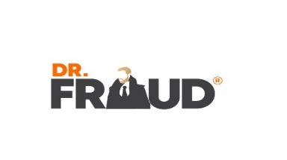
SPEECH SUMMARIES:
Dr. Fraud

- Psychology of Fraud
This session is founded on the presenters newly released book entitled, “The Psychology of Fraud”. This session will explore what motivates people (how honest are you??) as this is the basis for psychological and criminological research. Furthermore, attendees will gain an understanding of criminological theory and why fraudsters commit crime. These theories will be explored and applied in a fraud context which will assist with developing highly effective counter fraud strategies. Preventative efforts based on these theories will also be explored. Attend if you dare to get into the mind of a fraudster.

- What Makes Fraudsters Tick
Ever wonder what makes a person willing to commit fraud? Why doesn’t ethics and honesty kick in? Is it a push (motivational) factor or a pull (opportunity) factor that plays a bigger part? In this informative session, Dr. Fraud will explore all of these questions and dive into the mid-set of a fraudster. Gaining insights into the fraudsters mind will assist with developing stronger strategies for prevention, a key take-a-way from this session.

- PsychTech --Psychology of Technology
Technology is engulfing our society, from the IoT, social media, robotics, ML and AI. Learn how this technology is affecting human behavior and how companies are at increased risk. The session will begin by exploring how technology is growing at an incredible rate, putting more data and information into circulation than ever before. The session will then dive into psychological and criminological concepts focusing on how human behavior is changing as a result of technology. Attendees will then explore the mind of a fraudster and how scammers have also evolved tactics in this new tech era. Finally, different tactics to fight the new age criminal will be presented, providing attendees with valuable take-aways for application in their respective companies.

- PsychCom-The Psychology of Communication
In this session, Dr. Fraud will provide deep insights as to the core psychological elements of effective communication. Having a keen understanding of the deep level psychology behind communication will assist with enhancing communication skills and take them to the next level. Having an understanding of how people learn (three main learning styles) coupled with the five different types of personalities will assist will developing highly focused communication strategies in our evolving technology driven world.

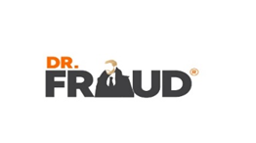
- ComTech-Communicating Effectively in a Technology World.
Dr. Fraud
What is the behavioral result of your teenager being on her phone 10 hours a day, or your office spending more time on virtual calls over in-person meetings, or when in public, people are more inclined to text a friend over talking to a “real” person standing next to them? Technology is engulfing our society, from the IoT, social media, robotics, ML and AI. Learn how this technology is affecting human behavior and furthermore how communication must evolve along with it. Communicating effectively today is vastly different than just a year ago. Learn the deep psychology behind communication and how to leverage this information to adapt communication styles to this new era. This session will provide the tools to communicate effectively in our current tech environment.

- Why People Cheat
Have you ever wondered what is at the root of cheating behavior? That is, what is the core motivation that would drive an individual to cheat in a given situation? This session will explore the psychological aspects of why people cheat and what are the main drivers of this behavior. Learn proven cheating prevention strategies that are based on these behavioral aspects.

- Corporate and Occupational Fraud
Corporate and occupational fraud is predicted to become one of the largest threats to companies and agencies in the upcoming year. Facing this internal threat requires a unique approach to counter-fraud, an approach that must be unique to that particular institution. In this very interactive session, learn specifics on schemes, detection methods, and strategies that can be taken away for immediate application. Furthermore, delve into the mind of the corporate fraudster and how their unique make-up requires equally unique tactics.

- Finding your Risk: Performing a Successful Vulnerability Assessment
Performing a vulnerability assessment is one of the most beneficial ways that a company can perform a health check of their fraud tactics, pain points, vulnerabilities, and opportunities. In this interactive session, learn specifics on how to perform this very important procedure from the perspective of Dr. Fraud, who has performed hundreds of assessments across the globe.

Dr. Fraud

- Clamping Down on Fraud
As the financial services industry continues to embrace data analytics, the fraud sector is seeing increasing benefits of implementation both domestically and abroad. Fraud is an international problem as business and manufacturing become more global. What impacts a company in Europe or Asia, will also affect companies in the U.S. and other countries. Cyber-attacks such as the WannaCry virus are an excellent example of how one event can have global repercussions. There are new tools, however, that will assist business owners in detecting and tracking the impact of fraud. This interactive session will focus on how data analytics is changing the fraud landscape.

- How to Create an Agile, Innovative Organization by Outrunning a Bear.
Technology is engulfing our society, from the IoT, social media, robotics, ML and AI. Learn how this technology is affecting human behavior and how organizations must pivot their strategies to survive, and thrive, in this highly volatile environment. In the outdoors, we have a saying that in order to survive a bear attack, you “don’t need to outrun the bear, just your friend”. Companies that focus on agility and adapt to these external factors will understand that they do not need to outrun that volatile, bear environment, but instead outrun their friends (non-agile organizations). Organizations that outrun their friend always survive! The session will begin with an exploration of how society is changing human behavior on a psychological level and how to leverage this into new, effective and focused business strategy.

- Inside the Mind of Your Audience.
Understanding who your audience is, is important, but even more critical is understanding how each of us learns in a different manner. We all receive and process information based on the different parts of our cognitive make-up. Communication approaches have to hit all three learning styles in order to reach all, not just a percentage, of the group or person you are speaking with. Understanding these three learning styles and how to connect and “reach” each style will make you a highly effective communication machine!

